A qualitative study overview using The Imagine Project as a reflective tool to increase empathy, intrinsic social emotional awareness, and reflective journaling through personal stories and events.

By:
Dr. Kimberle Jackson-Butler

June 2019

Abstract:

A child’s early years are critical for building the foundation for all future learning. The concept of reflective practice and reflective practitioners has been a part of the education profession since the writings of Dewey (1933). Social and emotional skill development continues to be a key component of early school programs. Teachers typically have skills that nurture the emotional intelligence of young children through their curriculum, writing, expressive play, cooperative learning groups, and unstructured learning periods. It is important for early childhood teachers to periodically challenge their own practices to make sure that they are consistently serving as good role models for regulating emotions particularly under stressful circumstances. Through reflective self-journaling and using The Imagine Project is a method that is a productive way to allow children to writing about their feelings, a traumatic and life changing events, and/or a personal story using the word “Imagine”.

Problem Statement

Social and emotional learning is a broad term that takes on different meanings depending upon the nature of the subject as it pertains to students, behavior, and academic achievement. According to current research, the definition of social and emotional learning encompasses five inter-related components:
- Self-awareness is the ability to take the perspective of and empathize with others from diverse backgrounds and diverse cultures. Social awareness is a crucial component of recognizing one’s own emotions and their influence, strength, and weaknesses.
- Self-management also referred to as “self-control” or “self-regulation,” is the ability to regulate one’s emotions, thoughts, and behaviors effectively in diverse environments. This includes managing stress, delaying gratification, motivating oneself, and setting and working toward personal and academic goals.
- Social awareness entails adopting the perspective of those with different backgrounds, understanding social and cultural norms, and recognizing available resources and supports.
- Relationship skills include establishing relationships with different kinds of people, communicating clearly, listening actively, cooperating, resisting inappropriate peer pressure, negotiating conflict, and seeking help when necessary.
- Responsible decision making is the capacity to make choices based on realistic evaluations of consequences, well-being, ethics, safety, and social norms.

As the benefits of social-emotional learning (SEL) have become clear, schools have seen a blossoming of programs that aim to equip students with fundamental strategies that increase executive functions, emotional learning, and interpersonal skills. The Imagine Project is a program whose mission is to ensure that all young people (K-12) are provided an opportunity to heal from stress and trauma through an expressive writing activity that uses the word “Imagine…” to begin every sentence. When kids are able to talk about their feelings, process challenging experiences, and Imagine a new story in their lives, they find hope and can move forward in learning and life. The Imagine Project is an interactive, 7-step expressive writing tool that can be used by teachers, parents at home, counselors and youth leaders in any organization that serves kids. Stress and trauma are prevalent in our society, children and teens need tools for support.

To gain a better understanding The Imagine Project is helping to create students to feel more comfortable in writing about their emotions and sharing their writing with others, a research study was conducted with elementary, middle and high school students. A separate research study was also conducted with undergraduate college students. The both populations were polled through surveys based on a mix-methodology approach to obtain demographic information, rating responses to questions based upon their reflective writing prompt to the word “Imagine” and qualitative questions to gather additional data about their writing experiences.

Background

Benefits of Reflective writing:

Reflective journal writing has many benefits with students.
- On one hand, students begin to write more clearly and more fluently. Students start to think more critically about their world and who they are.
- On the other hand, students like to learn how to be expressive in their writing, storytelling, and adding descriptive detail to explain their thoughts or events.
Students become more confident and grow as writers and thinkers. Through writing they are able to express their emotions and have an outlet that allows them to have a voice in their writing through their own perspective and how they experience a traumatic or stressful event in their life. Reflective writing is also an avenue that allows students to share their writing with others and opens avenues of dialog that reach other students who are have experienced the same or different events. This creates an empathic bond that is built on understanding, building trust, sharing experiences, developing listening skills, exploring diverse perspectives, developing commonalities, self-advocacy, and developing leadership skills.

This survey included questions to provide a qualitative narrative to this research. The research questions were designed to provide open-ended questions in a Pre-Test and Post-Test Survey response after the introduction and activity of The Imagine Project. The research questions are as follow:

- Describe what it's like for you to write about your feelings?
- Is there anything you would change about the Imagine Project?
- Do you think you are a good writer?
- Is there anything about the imagine project you would change?

Additionally, further data gathered from the results of this study would provide additional information that could enhance The Imagine Project for future use in expanding programming and development.

Executive Summary

- A Total of 404 respondents participated in the mixed-methodology study. This included elementary, middle and high school students, and undergraduate students.
- To better understand how The Imagine Project affects the outcome of students, the surveys were designed to capture responses through an online survey during the months of March, April, and May 2019.
- Although the sample is not statistically representative of the nation’s student population, the respondents were a diverse group of students representing a wide range of grade levels.
- The surveys addressed a range of topics related to social and emotional learning, including how students feel about the writing process, written expression, confidence, empathy, advocacy, hopes and dreams, kindness for others, and school/family worries.
- Among the surveyed elementary school age respondents, more than 90% said, they would not change anything about The Imagine Project. Below are some of their responses:
    - “I liked doing the whole thing I wouldn’t want to change anything.”
    - “Not really because then it would not be The Imagine Project.”
    - “No, I like the way it is.”
    - “I don’t think I would change anything.”
- When describing their favorite part about The Imagine Project, the majority of the elementary school age respondents expressed positive feedback. Below are some of their responses:
    - “Getting the feelings out that I have had to keep in.”
    - “Writing about things that are very sensitive to me helps to relieve the stress that comes with them.”
    - “Writing my dreams.”
    - “Letting people know about what I’ve gone through, and seeing what other people are going thought
    - “Teaching it to younger grades.”
    - “It helps to know there is a way to get around the hard things in life.”
- Among the surveyed middle school students, there were noticeable trends is the responses that varied from the elementary school age students. Some of these trends are noted their responses below:
    - “Taking about my deepest concerns.”
    - “I liked how you got to write about something that you cared about.”
    - “My favorite part was that we were able to write what we felt.”
    - “Listening to other people’s stories.”
    - “My favorite part was just being able to show people what I have gone through and to hear what others have been through.”
    - “The fact you could learn about others more.”
- Of the undergraduate college candidates surveyed, their responses were mixed when asked to describe what it’s like to write about your feelings. Below are some of their responses.
- “I prefer to talk about my feelings, not write about them.”
- “I don’t usually choose to write about my feelings. My writings about my feelings are not usually very elaborate.”
- “I think this is something I’ve always struggled with all throughout my life.”
- “It is a process which helps me copy with my feelings and be able to become more resilient with them.”
- “I get emotional and find it hard to keep writing. But once I’m done I usually feel a little better.”

- In general, the majority of the respondent from elementary to college felt they were good writers, were able to get their thoughts on paper, were imaginative, and enjoyed the process of writing.

METHODOLOGY

The research featured in this report is based on a survey developed for the purpose of gathering more data for The Imagine Project. The survey questions were designed as a mixed-method approach to understand how this reflective process of writing using the word “Imagine” to express feelings through writing and voluntarily sharing with others. The survey was distributed in the Spring of 2019 to a randomly selected sample of young elementary students through undergraduate college level students. The survey was designed to assess themes in writing/talking about feelings, life struggles, traumatic stress events, advocating, hopes and dreams, worries, and reflective writing.

RESPONDENT DEMOGRAPHICS

ELEMENTARY STUDENTS

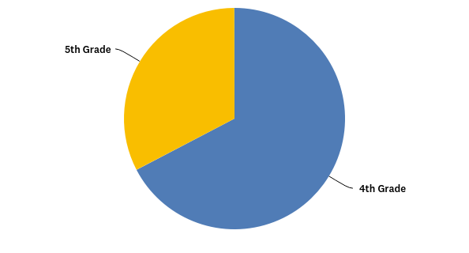

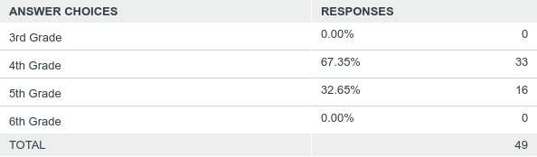

MS STUDENTS
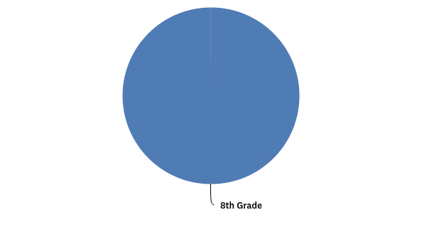
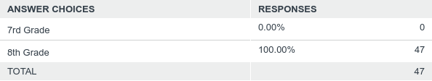

HIGH SCHOOL STUDENTS

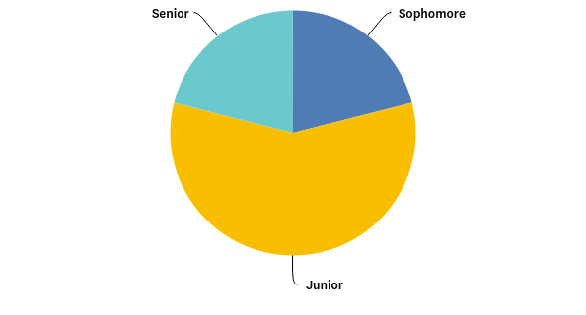

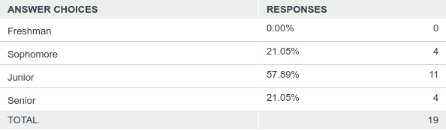

UNDERGRADUATE STUDENTS
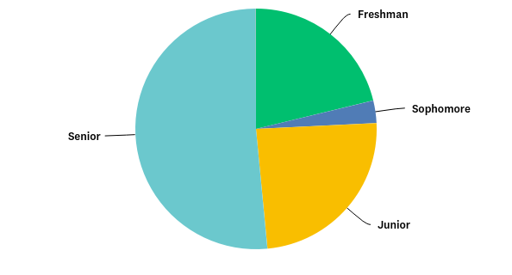

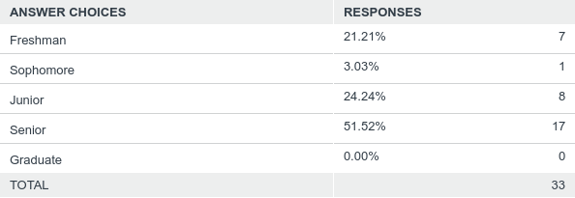

Learning through reflective writing:

For the majority of students, researchers have found that students’ experiences are viewed in isolation and not easily shared among their peers. For some students expressing their emotions can be challenging, and often too painful to talk about even with teachers or school counselors. Writing about certain experiences often provides a student with the tools to cope with traumatic life events in a way that allows them to express themselves without judgement through self-reflection, and introspective life-lessons.

Teachers, counselors, and others who work with students want students to have strategies that will help students cope with traumatic events as they get older and understand that their experiences although they might be different from others is a way to increase empathy, understand differences, and open to connecting and communicating with others. Such work requires reflection.

Reflection has many facets. For example, reflecting on work enhances its meaning. Reflecting on experiences encourages insight and complex learning. Reflection fosters personal growth in learning and reflection is also enhanced when students ponder their learning with others. Reflection involves linking a current experience to previous learnings (a process called scaffolding). Reflection also involves drawing forth cognitive and emotional information from several sources: visual, auditory, kinesthetic, and tactile. To reflect, students must act upon and process the information, synthesizing and evaluating the data. In the end, reflecting also means applying what students have learned to contexts beyond the original situations in which they learned something.

Teachers who promote reflective classrooms to ensure that students are fully engaged in the process of making meaning. Teachers organize instruction so that students are the producers and not just the consumers of knowledge. In guiding students to form reflection, teachers approach their role as that of "facilitator of meaning making." In the role of facilitator, the teacher acts as an intermediary between the learner and the learning, to help guiding each student to approach the learning activity in a strategic way. The teacher helps each student monitor individual progress, construct meaning from the content learned and from the process of learning it, and apply the learnings to other contexts and settings. Learning becomes a continual process of engaging the mind that transforms the mind.

Discussions

Encouraging reflection is as simple as inviting students to think about their thinking. Students realize meaning making is an important goal when reflection becomes the topic of discussion. Students voluntarily share their “Imagine” story which creates the rich of discussions with their peers, students learn how to listen and explore the implications of each other's metacognitive strategies through their stories and find ways to connect with other students. This kind of listening requires the type of connections that builds the habits of mind related to empathy, flexibility, and persistence.
Conclusion

Learning effective ways to manage stress is especially important for all children. Chronic stress is particularly troublesome for children, because among many other effects, it can disrupt still-developing white matter in the brain, causing long-term problems with complex thinking and memory skills, attention, learning and behavior. Researchers have found that the ways students cope are highly personal, and providing students with coping strategies allows them to utilizing these strategies in a way that supports the developmental growth and to express their emotions. When subjects used adaptive strategies, like looking at a problem in a different way, writing their feelings to express their emotions they begin engaging in problem solving or pursuing constructive communication, they are better able to manage the adverse effects of stress. Students who used maladaptive strategies like suppressing, avoiding or denying their feelings, have higher levels of problems associated with stress.

Stress is the single most potent risk factor for mental health problems in children and adolescents, including depression, anxiety, post-traumatic stress syndrome, eating disorders and substance use. However, the brain is malleable. Once positive coping skills are learned and put into practice, especially starting at the early ages in learning, students have the ability to manage stress for a lifetime.

The Imagine Project is a resourceful tool that teachers can easily implement directly into their lesson plans. The Imagine Project continues to grow with students and helping them develop not only coping strategies but develop their own leadership skills that allows students to teach and mentor younger students the activity of writing their own stories. This process continues to build classroom and community engagement, empathy, and peer to peer relations.

APPENDIX AND SURVEY INSTRUMENTS

ELEMENTARY SCHOOL SURVEY
Student Survey 3rd - 6th Grades
1. Name of School:
2. Please check your grade:
- 3rd Grade
- 4th Grade
- 5th Grade
- 6th Grade
3. Please check:
- Male
- Female
4. Do you like to write?
- Always
- Usually
- Sometimes
- Rarely
- Never
5. Do you like to talk about your feelings?
- Always
- Usually
- Sometimes
- Rarely
- Never
6. When I am in school I worry.
- Always
- Usually
- Sometimes
- Rarely
- Never
7. When I am in school I worry about (Check all that apply):
- My schoolwork
- My family
- My friends
- None of the above
8. Do you like to write about your feelings?
- Always
- Usually
- Sometimes
- Rarely
- Never
9. When I'm in school I can focus better when I don't worry.
- Always
- Usually
- Sometimes
- Rarely
- Never
10. It’s important to be kind to others.
- Always
- Usually
- Sometimes
- Rarely
- Never
11. I feel good/confident about my work at school.
- Always
- Usually
- Sometimes
- Rarely
- Never
12. I know how to help myself when I am sad or unhappy.
- Always
- Usually
- Sometimes
- Rarely
- Never

13. I know how to help others when they are sad or unhappy.
- Always
- Usually
- Sometimes
- Rarely
- Never
14. I know I can overcome anything.
- Always
- Usually
- Sometimes
- Rarely
- Never
15. I feel bad when I see others who are sad or unhappy.
- Always
- Usually
- Sometimes
- Rarely
- Never
16. I like to hang out with kids (people) that like to do the same things I do.
- Always
- Usually
- Sometimes
- Rarely
- Never

17. I believe I can make my dreams come true.
- Always
- Usually
- Sometimes
- Rarely
- Never
18. Describe what it's like for you to write about your feelings?
19. Do you think you are a good writer? Why or why not.

MIDDLE SCHOOL SURVEY INSTRUMENT

1. School:
2. Please check your grade:
- 7rd Grade
- 8th Grade
3. Please check:
- Male
- Female
4. Do you like writing?
- Always
- Usually
- Sometimes
- Rarely
- Never
5. Do you like writing about your feelings.
- Always
- Usually
- Sometimes
- Rarely
- Never
6. Do you like to talk about your feelings.
- Always
- Usually
- Sometimes
- Rarely
- Never
7. When I am in school I worry.
- Always
- Usually
- Sometimes
- Rarely
- Never
8. When I am in school I worry about (Check all that apply):
- My schoolwork
- My family
- My friends
- Something else
9. When I'm in school I can focus better when I don't worry.
- Always
- Usually
- Sometimes
- Rarely
- Never
10. It’s important to be kind to others.
- Always
- Usually
- Sometimes
- Rarely
- Never

11. I feel good/confident about my work at school.
- Always
- Usually
- Sometimes
- Rarely
- Never
12. I know how to help myself when I am struggling with something in life.
- Always
- Usually
- Sometimes
- Rarely
- Never
13. I know how to help others when they are upset.
- Always
- Usually
- Sometimes
- Rarely
- Never

14. I know how to advocate for myself and for others.
- Always
- Usually
- Sometimes
- Rarely
- Never

15. I know I can overcome anything.
- Always
- Usually
- Sometimes
- Rarely
- Never
16. I feel bad when I see others who are upset or struggling.
- Always
- Usually
- Sometimes
- Rarely
- Never

17. I like to hang out with kids (people) that like to do the same things I do.
- Always
- Usually
- Sometimes
- Rarely
- Never
18. I believe I can make my dreams come true.
- Always
- Usually
- Sometimes
- Rarely
- Never
19. Describe what it's like for you to write about your feelings?
20. Do you think you are a good writer? Why or why not.

HIGH SCHOOL SURVEY INSTRUMENT
1. School:
2. Please check your grade:
- Freshman
- Sophomore
- Junior
- Senior
3. Please check:
- Male
- Female
4. Do you like writing?
- Always
- Usually
- Sometimes
- Rarely
- Never
5. Do you like writing about your feelings.
- Always
- Usually
- Sometimes
- Rarely
- Never
6. Do you like to talk about your feelings.
- Always
- Usually
- Sometimes
- Rarely
- Never
7. When I am in school I worry.
- Always
- Usually
- Sometimes
- Rarely
- Never

8. When I am in school I worry about (Check all that apply):
- My schoolwork
- My family
- My friends
- Something else
9. When I'm in school I can focus better when I don't worry.
- Always
- Usually
- Sometimes
- Rarely
- Never
10. It’s important to be kind to others.
- Always
- Usually
- Sometimes
- Rarely
- Never

11. I feel good/confident about my work at school.
- Always
- Usually
- Sometimes
- Rarely
- Never
12. I know how to help myself when I am struggling with something in life.
- Always
- Usually
- Sometimes
- Rarely
- Never
13. I know how to help others when they are upset.
- Always
- Usually
- Sometimes
- Rarely
- Never

14. I know how to advocate for myself and for others.
- Always
- Usually
- Sometimes
- Rarely
- Never

15. I know I can overcome anything.
- Always
- Usually
- Sometimes
- Rarely
- Never
16. I feel bad when I see others who are upset or struggling.
- Always
- Usually
- Sometimes
- Rarely
- Never
17. I like to hang out with kids (people) that like to do the same things I do.
- Always
- Usually
- Sometimes
- Rarely
- Never
18. I believe I can make my dreams come true.
- Always
- Usually
- Sometimes
- Rarely
- Never
19. Describe what it's like for you to write about your feelings?
20. Do you think you are a good writer? Why or why not.

UNDERGRADUATE STUDENT TEACHER SURVEY INSTRUMENT
1. Are you currently teaching?
- Yes
- No
2. If yes, where are you (student) teaching?
3. Please check your year:
Freshman Sophomore Junior Senior Graduate
4. Please check:
- Male
- Female
- Other
5. Do you like writing?
- Always
- Usually
- Sometimes
- Rarely
- Never
6. I like writing about my feelings.
- Always
- Usually
- Sometimes
- Rarely
- Never
7. I like talking about my feelings.
- Always
- Usually
- Sometimes
- Rarely
- Never

8. When I am in school I worry.
- Always
- Usually
- Sometimes
- Rarely
- Never
9. When I am in school I worry about (Check all that apply):
- My schoolwork.
- My family
- My friends
- Something else
10. When I'm in school I can focus better when I don't worry.
- Always
- Usually
- Sometimes
- Rarely
- Never
11. I know how to help others when they are upset.
- Always
- Usually
- Sometimes
- Rarely
- Never
12. It’s important to be kind to others.
- Always
- Usually
- Sometimes
- Rarely
- Never
13. I feel good/confident about my work at school.
- Always
- Usually
- Sometimes
- Rarely
- Never

14. I know how to help myself when I am struggling with something in life.
- Always
- Usually
- Sometimes
- Rarely
- Never
15. I know how to advocate for myself and for others.
- Always
- Usually
- Sometimes
- Rarely
- Never

16. I know I can overcome anything.
- Always
- Usually
- Sometimes
- Rarely
- Never
17. I feel bad when I see others who are upset or struggling.
- Always
- Usually
- Sometimes
- Rarely
- Never
18. I like to hang out with others that like to do the same things I like to do
- Always
- Usually
- Sometimes
- Rarely
- Never
19. I believe I can make my dreams come true.
- Always
- Usually
- Sometimes
- Rarely
- Never
20. Describe what it's like for you to write about your feelings?
21. Do you think you are a good writer? Why or why not.

