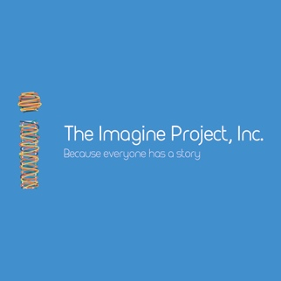
The Imagine Project is coming to ____________!

Dear Parents,
We are happy to share with you that on _____________________ The Imagine Project will be coming to ______________________.
The Imagine Project, Inc. is a 501(c)(3) nonprofit organization that supports kids and teens with social-emotional learning and community awareness.
The Imagine Project is an expressive writing tool that includes a step-by-step process where students write about a story in their lives, past or present, that may have impacted them. This process gives students an opportunity to express, let it go (if needed) and then they are guided to Imagine new possibilities in their lives. The kids use a 7-step journal that takes them through a simple process of writing (and/or drawing) and rewriting their own life story. One step includes the opportunity to share their stories with others in the classroom—kids can choose whether or not to share. The process of sharing can sometimes be emotional yet powerful because the kids are able to speak what’s in their hearts and hear the stories of other classmates—which often leads to bonding and friendships that weren’t there before.
As parents, The Imagine Project gives you an opportunity to talk with your child, and teachers if you wish, about what he or she is feeling. It’s powerful for everyone. If you’d like review or even download the journals to use at home, please visit www.theimagineproject.org.
The Imagine Project was created to give kids and teens a voice for positive change in their lives, and as they move forward in the world. Other schools have said wonderful things about the writing process and we are excited to bring this to your school! Research is showing that The Imagine Project increases resilience, improves optimism, adaptability and self-improvement in our kids, and creates a remarkable sense of community between students and teachers.
Please feel free to ask your child’s teacher about The Imagine Project and explore his or her stories with them. We invite you to visit www.theimagineproject.org for more information.
Thank you!

